Our Apples
Because Anthony's Orchard is a family run orchard, we grow every apple to be delicious and healthy for you and your family just like we would for ours. We choose only the highest-quality trees and carefully select varieties that thrive in Wenatchee Valley.

Anthony's Orchard currently features:

Braeburn
These beautiful red-orange apples burst with flavors that are both sweet and crisp. One bite is all you'll need to discover that Braeburn apples make a perfect snack for you or the kids. A hybrid descended from the Granny Smith variety, they also retain some of that apple's signature tartness and are ideal for cooking in desserts and applesauce.
- Chomp or cook: perfect for both!
- Season: October - July
Honeycrisp
Intense flavors and unique colors combine in this versatile apple. A mix of green and red colors complement the mix of sweet and tart flavors. Although small in size, Honeycrisp lives up to its namesake with a sweet and crunchy experience waiting in every bite. The tart flavors and dense texture also work great in your favorite pies or applesauce.
All Anthony's Orchard apple pies feature fresh and delicious Honeycrisp apples right from our orchard.
- Chomp or cook: perfect for both!
- Season: October - May

Prepared Apple Products Just Like Mom's
At Anthony's Orchard, we use time-honored family recipes to make all of our apple products. The result? Simply amazing pies and applesauce made with fresh and natural ingredients. The only thing missing is mom's oven.
Apple Pie Filling
Treat your family to a hot, fresh apple pie without the hassle using our prepared apple pie filling. We start with our freshly picked Honeycrisp apples; wash, core, and dice them; and prepare the filling with our secret family recipe, all in our own kitchen.
Available now in our orchard store and at local retailers.
Applesauce
Hot or cold, applesauce is a year-round treat. Our Braeburn and Honeycrisp apples give just enough sweet and tart flavors for a refreshing applesauce that's perfect for breakfast, lunch, dinner, or dessert.
Available now in our orchard store and at local retailers.
Where to Find Our Apple Products
Anthony's Orchard works with a several national retail outlets. Just look for our logo next time you're in the apple aisle at your local market!

Pick Your Own Apples
Bring the whole family and pick as many apples as you can carry. The orchard is open during apple season 8 a.m. to 6 p.m. daily. We sell all of our apple varieties by the pound. Bring your own bag and we offer a discount.
Thanks to all the wonderful folks who continue visiting our Orchard.
See you soon!
CSA Program, May - August
Our Community Supported Agriculture (CSA) program is a win-win for you and for us. You get the best selection of our apples, picked and delivered weekly right to your door. And you help Anthony's Orchard by becoming a loyal patron of our hard work.
We'll deliver your CSA every Wednesday through our peak season, May – June for our Honeycrisp apples and July – August for our Braeburn apples. You can participate in our CSA as a full share member (for a family of four) or half share member (for a family of two):
- Full share: 2 dozen per week, £10
- Half share: 1 dozen per week, £5
For more information visit our store or look for a flyer at your local market
Fall Harvest Festival, October 1 - 31
Join us for our annual Fall Harvest Festival during the month of October with tricks and treats for the young and the young at heart. Take a spooktacular hayride through the orchard and over to our pumpkin patch, where you can pick out your very own future jack-o-lantern. Just watch out for our very own phantom of the orchard, old Apple Lloyd Webber!
Educational Programs
Turn our orchard into your classroom with special programs designed to enhance learning and build appreciation for farming and agriculture. Guided tours through the orchard and production facilities offer students an opportunity to learn more about where their food comes from and how it moves from the field to the market. We'll also work with you to tailor the lessons to meet the needs of your class' age group and your curriculum

Welcome to the Apple Store
You'll find plenty of our fresh apples, apple products, and other items like kitchen tools designed to help you turn apples into awesome.
Products:
- Fresh Braeburn and Honeycrisp apples from our orchard (available year-round)
- Apple pie filling
- Applesauce
- Cookbooks
- Apple presses, peelers, and corers
- Other apple merchandise
Note: exact product selection may vary.
Store Hours: 7 days a week, 8 a.m. to 6 p.m.
Location: Once you arrive at the orchard, turn left and follow the road to the big red barn. Look for the red door on the right.

About Anthony's Orchard
Anthony's Orchards is a 3rd-generation, family-owned 6,000-acre orchard situated in Wenatchee Valley, the heart of apple producing in Washington State. Surrounded by gently rolling mountains Anthony's Orchard has been growing apples in the valley for over 60 years. Our waterfront orchards line the region's rushing rivers. The nutrient-rich soil and our advanced growing practices provide the right mix for producing some of the world's top-quality apples. Washington State has been known for its apples and produces a wide variety. At Anthony's Orchard, we have focused on two varieties of apples: Braeburn and Honeycrisp.
Mission Statement
Our mission is to continually enhance consumers' awareness of apples and apple orchards.
Vision Statement
Our vision is to provide the best apple products and services to our customers and generate returns for our shareholders, while enhancing the well being of our community.
Careers at Anthony's Orchard
Looking for a fulfilling career in apples? It may not be the Big Apple, but in addition to a great benefits package, Anthony's Orchard offers all the clean air and fresh fruit you could ever want.
Investor Information
Crunch into the financial information on our Investor Relations page. You'll find the data as crisp and fresh as this morning's harvest.

Careers at Anthony's Orchard
Anthony's Orchard employs about 300 year-round staff plus several hundred more during peak harvest seasons. We are currently seeking candidates for the following positions:
Retail Store Sales Manager
The Sales Manager is directly responsible for overseeing the supervision and delegation of associates and staff, managing expenses, achieving profitability goals, and overseeing the corporate merchandising, and the overall management of the retail store while overseeing customer satisfaction.
For a full job description please contact Tara Olsen in our HR Department
Lead Outside Sales Rep
The Lead Outside Sales Rep is responsible for leading and overseeing sales operations with our retail partner accounts, managing inventory logistics, and managing staff scheduling, training, and development.
For a full job description please contact Tara Olsen in our HR Department
Field Trip Leader (Community Outreach Program)
Love working with kids? We need a rock star field trip leader to provide excellent customer service to our school group guests and lead on-site learning programs.
For a full job description please contact Tara Olsen in our HR Department

Information for Investors
Organizational Structure
Learn more about how Anthony's Orchard is structured, from our executive committee to the front lines in the orchard
Webcasts and Presentations
Explore these freshly picked earnings calls and financial information for investors
Strategic Plan
See our plan to cultivate and grow financial success through cultivating and growing apples and apple product lines
Financial Information and Charts
See our current year budget and costs information
- Budget Overview
- Auditing Overview

Organizational Structure
- Executive Committee:
  - Bob Frost, CEO
  - Mary Scott, CFO of Finance
  - John Daniels, SVP of Sales
  - Samir Saeed, SVP of Operations
- Departmental Units:
  - Human Resources
    - Leonard Pulanski, Director of Human Resources
      - Chuck West, Benefits Manager
      - Brenda Norris, Payroll Manager
      - Tara Olsen, Recruiting Manager
        - Heather Mullins, Seasonal Labor Coordinator
      - Sean Manning, Training Manager
  - Marketing
    - Christine Miller, Director of Marketing
      - Darrius Mason, Marketing Manager
        - Kat Williams, Marketing Coordinator
        - Trevor Lewis, Market Research Analyst
        - Evan Beam, Marketing Intern
        - Jim Wiliams, Marketing Intern
        - Jack Walker, Marketing Intern
    - Bill Owens, Director of Communications
  - Sales
    - Director of Sales
      - Lead Outside Sales Rep (open)
        - Neil Faraday, Northeast US Sales Rep
        - Max Curie, Southeast US Sales Rep
        - Marie Planck, Central US Sales Rep
        - Michael Bohr, Western US Sales Rep
  - Operations & Processing
    - Allison Sinclair, Director of Operations
      - Ben Arshavin, Processing Manager
        - Felicia Jennings, Processing Floor Supervisor
        - Todd Driver, Processing Floor Supervisor
          - Processing staff (seasonal)
      - Retail Store Sales Manager (open)
        - Sun Kim, Retail Sore Supervisor
        - Taressa Johnson, Retail Store Supervisor
          - Retail Staff (seasonal)
        - CSA Supervisor
      - Shaleish Gupta, Educational Programs Manager
        - Field Trip Leader (open)
      - Shamus McFadden, Orchard Manager
        - Leo Richards, Orchard Supervisor
        - Don Smith, Orchard Supervisor
        - Mike Jones, Orchard Supervisor
        - Raphael Zirpolo, Orchard Supervisor
          - Orchard workers (seasonal)
      - AJ Martin, Purchasing Manager
      - Gabriella Nickel, Warehouse Manager
  - Finance & Accounting
    - Jeanine Lister, Director of Finance
      - Pamela Kirk, Accounting Manager
        - Scott Michaels, Accounts Payable Manager
        - Marsha Birch, Accounts Receivable Manager
  - Information Technology
    - Ted Schaeffer, Director of Information Technology
      - Bob O'Malley, Systems Manager
      - Martin Erlich, Website Manager
Note: seasonal staffing levels vary to meet business needs

Webcasts and Presentations
Earnings calls are designed to provide disclosure and financial results for a certain reporting period. In addition, earnings calls provide transparency and can help with forecasting and planning.

Strategic Plan & Growth Initiatives
Please see below for excerpts from our Long Term Vision and strategic planning sessions:
- In 2012, the Company is hoping to purchase an apple press, which would allow us to start a new line of prepared apple products – apple juice. Our plans include an estimated $95,000 net income per year and an estimated $90,000 of cash inflows per year from the new line of apple juice. We expect a 10% return on this investment.
- We continue to search for new orchards throughout the country so that we may diversify the types of apples we produce. While we feel that Braeburn and Honeycrisp are among the best, we understand that you the customers might like additional variety.
- Our 2015 revenue goal is to exceed $25 million dollars, which will involve either acquiring new orchards, or expanding our line of products.

Financial Information and Charts
Budget Overview
Anthony's Orchard begins budget planning each year in August and finalized by the start of our fiscal year in October. Each departmental director, as defined by the company's organizational structure, provides labor and materials cost forecasts. The Senior VP of Operations compiles these numbers to estimate total costs. The Senior VP of Sales forecasts sales based on fruit yield estimates from the Operations division, and the Senior VP of Finance prepares the final annual budget for approval by the Executive Committee and Board of Directors.
Anthony's Orchard uses a FIFO accounting method to minimize crop waste. Factory overhead uses a flexible budget to respond to business demands and scale with crop yield. Variable overhead varies with the number of direct labor hours in operations areas, including processing, retail store, and harvesting.
Budget info and financial data
- Budgets
- Previous Year Financial
- Current Year Financial

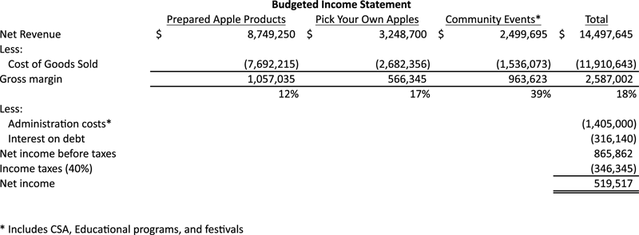

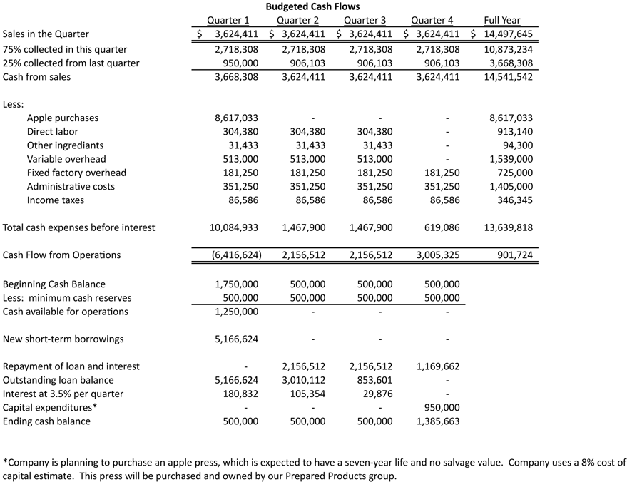

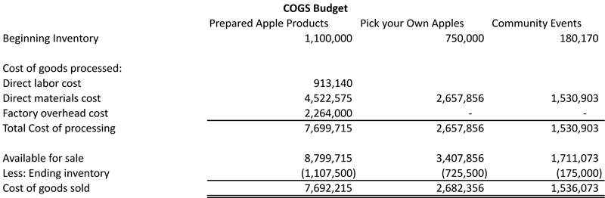

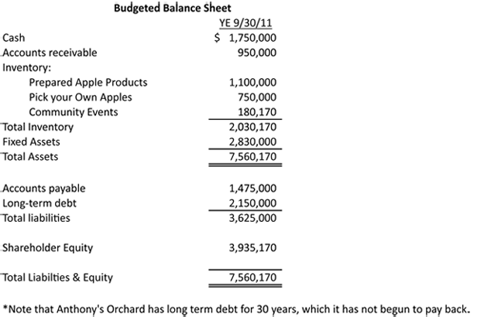

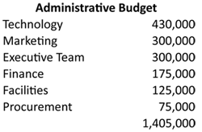

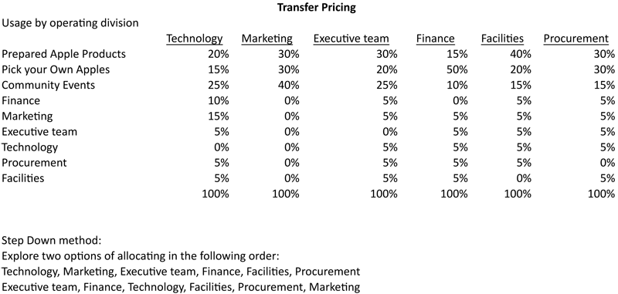

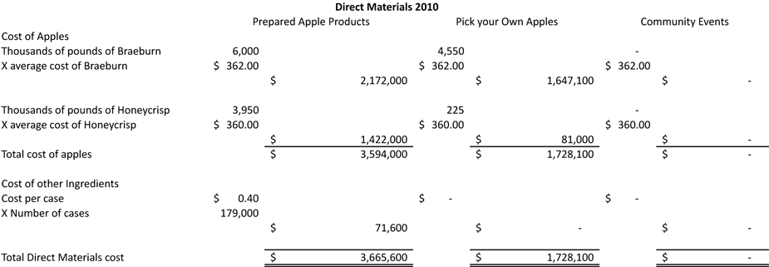

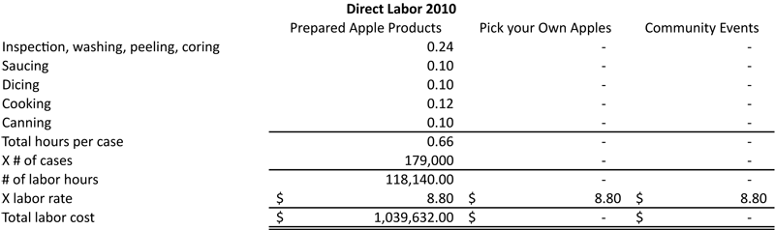

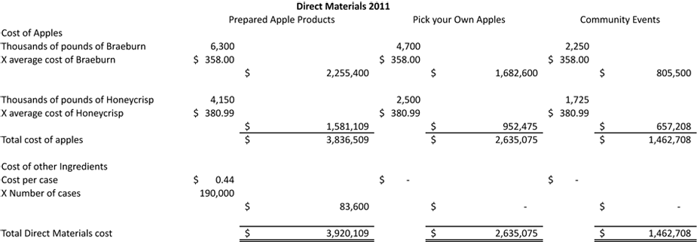

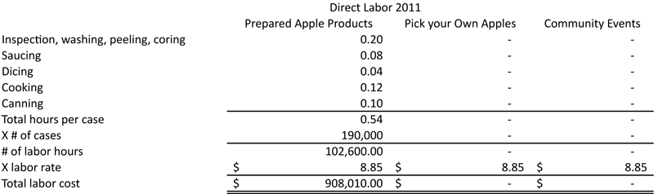

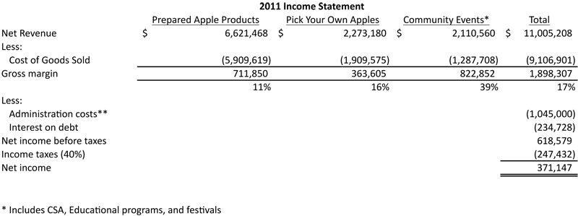

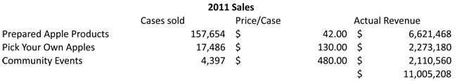

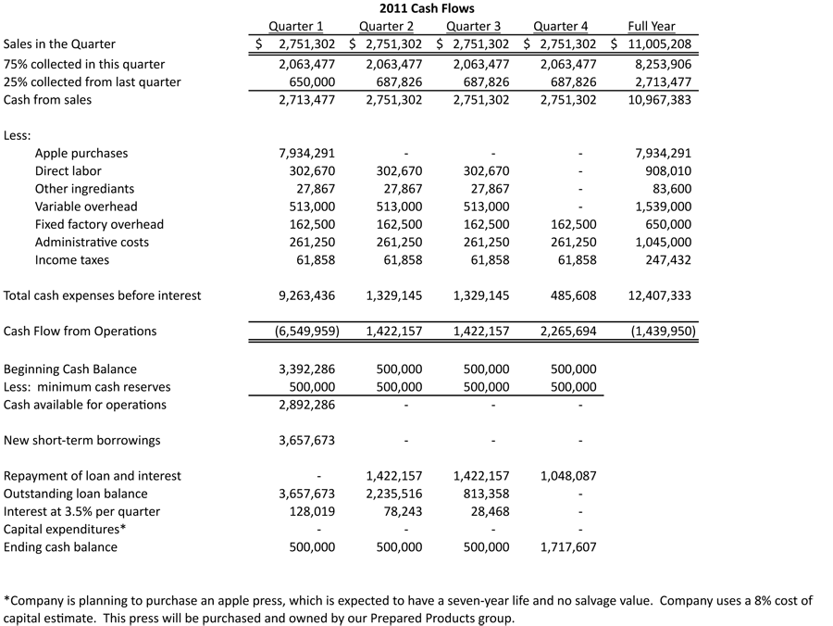

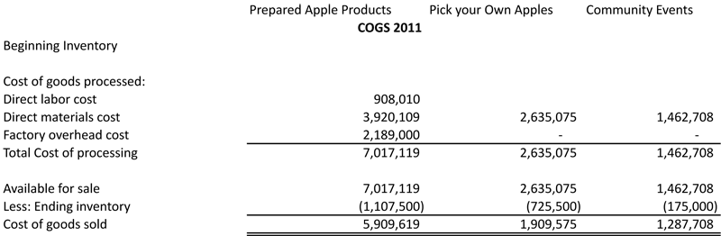

Auditing Overview
Anthony's Orchard has made a request to the Securities and Exchange Commission (SEC) to change their fiscal year from September to December. The request has been granted and a national accounting audit firm, Ethical and Integrity (E & I), has been engaged to provide an opinion on the financial statements ending December 2009.
Under the Sarbanes-Oxley Act of 2002, Anthony's Orchard Audit Committee, which is comprised of the Internal Auditing Department, is responsible for the oversight of the independent auditor. In addition, The Audit Committee is responsible for obtaining the appropriate input from management and considers the type and scope of work to be performed by the auditor and the audit fees associated with the audit.
The Audit Committee must comply and follow the SEC's rules on auditor independence. Anthony's Orchard personnel must ensure not to impair or interfere with the auditor's independence. Personnel must not engage, in any circumstance, in services that are not permissible.
The Audit Committee has attested to the internal controls over financial reporting as of year-end, section 404.

